PART A: DATA
The dataset pairs, for the same 20 countries in the same year (2019, the last full year before COVID-19 disrupted global mortality trends), the density of physicians in the health workforce with the population's life expectancy at birth. The hypothesis is that countries with more physicians per capita tend to have better access to health care and therefore higher life expectancy.
X VARIABLE: Physicians per 1,000 people (density)
Physicians (per 1,000 people), 2019. World Health Organization (Global Health Workforce Statistics), compiled via World Bank World Development Indicators. Retrieved from: https://ourworldindata.org/grapher/physicians-per-1000-people
Y VARIABLE: Life expectancy at birth, years
Life expectancy at birth, both sexes (years), 2019. World Health Organization Global Health Observatory (GHO). Retrieved from: https://www.who.int/data/gho/data/indicators/indicator-details/GHO/life-expectancy-at-birth-(years)
Country | x: Physicians / 1,000 | y: Life Expectancy (yrs)
Afghanistan | 0.214 | 61.22
Albania | 1.645 | 77.94
Argentina | 5.250 | 77.02
Australia | 3.808 | 82.64
Bangladesh | 0.630 | 73.95
Belgium | 3.424 | 81.61
Brazil | 2.351 | 75.48
Canada | 2.418 | 82.02
Chile | 2.627 | 81.03
China | 2.255 | 77.31
Colombia | 2.317 | 77.95
Egypt | 0.697 | 71.59
Germany | 4.373 | 80.97
India | 0.889 | 70.73
Indonesia | 0.462 | 71.40
Italy | 4.024 | 82.98
Malaysia | 2.021 | 74.68
Mexico | 2.460 | 75.83
Nepal | 0.815 | 71.36
Philippines | 0.732 | 69.43

PART B: CODE
"""
Lab 03: Real-World Data Linear Regression
Numerical Methods, Section 3H
Student: Cyril John T. Jamison

Data source: World Health Organization (WHO)
x = Physicians (per 1,000 people), 2019
World Health Organization (Global Health Workforce Statistics), via
World Bank World Development Indicators.
https://ourworldindata.org/grapher/physicians-per-1000-people
y = Life expectancy at birth, both sexes (years), 2019
World Health Organization - Global Health Observatory (GHO)
https://www.who.int/data/gho/data/indicators/indicator-details/GHO/life-expectancy

Both variables were retrieved for the same 20 countries and the same year
(2019, the last full year before COVID-19 disrupted life-expectancy trends).
"""

import numpy as np
import matplotlib.pyplot as plt

# =================================================================
# SECTION 1: DATA - physicians per 1,000 people (x) and life
# expectancy at birth in years (y), 20 countries, 2019
# =================================================================
countries = [
"Afghanistan", "Albania", "Argentina", "Australia", "Bangladesh",
"Belgium", "Brazil", "Canada", "Chile", "China",
"Colombia", "Egypt", "Germany", "India",
"Indonesia", "Italy", "Malaysia", "Mexico", "Nepal",
"Philippines",
]

# x: physicians per 1,000 people
x = np.array([
0.214, 1.645, 5.250, 3.808, 0.630,
3.424, 2.351, 2.418, 2.627, 2.255,
2.317, 0.697, 4.373, 0.889,
0.462, 4.024, 2.021, 2.460, 0.815,
0.732,
])

# y: life expectancy at birth, years
y = np.array([
61.224, 77.941, 77.016, 82.642, 73.950,
81.609, 75.478, 82.022, 81.028, 77.313,
77.954, 71.590, 80.974, 70.727,
71.401, 82.985, 74.684, 75.834, 71.361,
69.429,
])

n = len(x)

# =================================================================
# SECTION 2: LEAST-SQUARES COEFFICIENTS a0 AND a1
# Fit the model y = a0 + a1*x using the normal
# equations (no Excel trendline, no numpy.polyfit)
# =================================================================
sum_x = np.sum(x)
sum_y = np.sum(y)
sum_xy = np.sum(x * y)
sum_x2 = np.sum(x ** 2)

a1 = (n * sum_xy - sum_x * sum_y) / (n * sum_x2 - sum_x ** 2)
a0 = (sum_y - a1 * sum_x) / n

print("SECTION 2: Least-squares coefficients")
print(f" a0 (intercept) = {a0:.4f}")
print(f" a1 (slope) = {a1:.4f}")
print(f" Regression equation: y = {a0:.4f} + {a1:.4f} x")
print()

# =================================================================
# SECTION 3: PREDICTED VALUES AND RESIDUALS
# y_pred = a0 + a1*x for every data point;
# residual = observed y minus predicted y
# =================================================================
y_pred = a0 + a1 * x
residuals = y - y_pred

print("SECTION 3: Predicted values and residuals")
print(f"{'Country':<14}{'x':>8}{'y (obs)':>10}{'y (pred)':>10}{'residual':>10}")
for c, xi, yi, ypi, ri in zip(countries, x, y, y_pred, residuals):
print(f"{c:<14}{xi:>8.3f}{yi:>10.3f}{ypi:>10.3f}{ri:>10.3f}")
print()

# =================================================================
# SECTION 4: GOODNESS OF FIT - Sr (SSE), r^2, standard error sy/x
# =================================================================
St = np.sum((y - np.mean(y)) ** 2) # total sum of squares
Sr = np.sum(residuals ** 2) # sum of squared errors (SSE)
r2 = 1 - Sr / St # coefficient of determination
syx = np.sqrt(Sr / (n - 2)) # standard error of the estimate

print("SECTION 4: Goodness of fit")
print(f" Sr (SSE) = {Sr:.4f}")
print(f" r^2 = {r2:.4f}")
print(f" standard error s_y/x = {syx:.4f} years")
print()

# =================================================================
# SECTION 5: PREDICTION FOR AN x NOT IN THE DATASET
# =================================================================
x_new = 3.0 # physicians per 1,000 people
y_new = a0 + a1 * x_new

print("SECTION 5: Prediction for a new x")
print(f" x = {x_new} physicians/1,000 -> predicted y = {y_new:.2f} years")
print()

# =================================================================
# SECTION 6: PLOTS - data with fitted line, and residual plot
# =================================================================
# Data + fitted line
plt.figure(figsize=(6, 4.5))
plt.scatter(x, y, color="#1f4e79", label="Country data (2019)")
x_line = np.linspace(min(x), max(x), 100)
plt.plot(x_line, a0 + a1 * x_line, color="#c8963e",
label=f"y = {a0:.2f} + {a1:.2f}x")
plt.xlabel("Physicians (per 1,000 people)")
plt.ylabel("Life expectancy at birth (years)")
plt.title("Life Expectancy vs. Physician Density (WHO, 2019)")
plt.legend()
plt.tight_layout()
plt.savefig("fit_plot.png", dpi=150)
plt.close()

# Residual plot
plt.figure(figsize=(6, 4.5))
plt.scatter(x, residuals, color="#1f4e79")
plt.axhline(0, color="#c8963e", linewidth=1.5)
plt.xlabel("Physicians (per 1,000 people)")
plt.ylabel("Residual (years)")
plt.title("Residual Plot")
plt.tight_layout()
plt.savefig("residual_plot.png", dpi=150)
plt.close()

print("SECTION 6: Plots saved as fit_plot.png and residual_plot.png")

PART C: RESULTS
y = 69.4368 + 2.9583 x
Slope a1 = 2.9583 | Intercept a0 = 69.4368
STATISTICS | VALUE
S_r (SSE) | 231.91 years²
r² (coefficient of determination) | 0.5989
Standard error, s_y/x | 3.59 years

RESULTS SHOWN IN A SCATTER PLOT AND LINEAR REGRESSION:
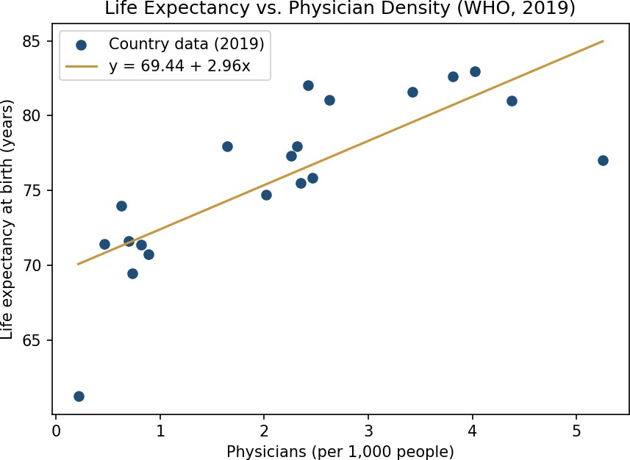

RESIDUAL PLOT:
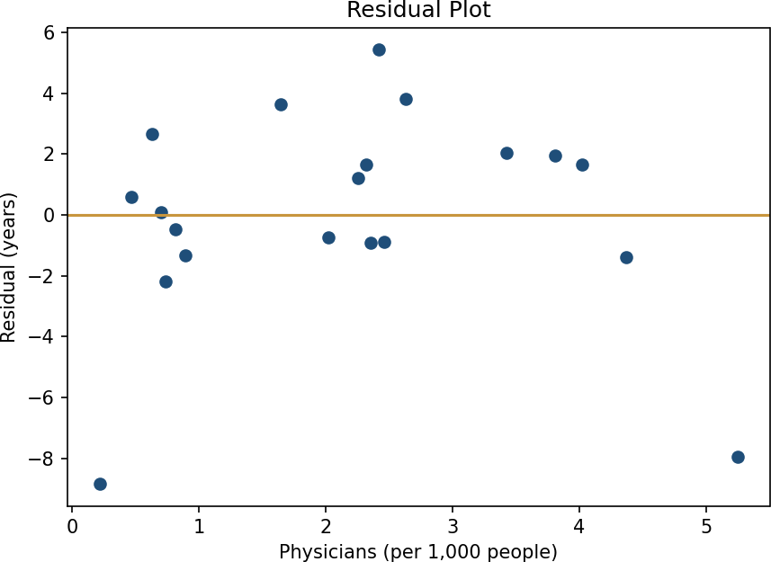

PREDICTION:
For a country with x = 3.0 physicians per 1,000 people (a value not in the dataset, roughly between Colombia's 2.32 and Belgium's 3.42):
y = 69.4368 + 2.9583(3.0) = 78.31 years
This prediction is meaningful because x = 3.0 falls within the range of physician densities observed in the dataset (0.21 to 5.25), so it is an interpolation rather than an extrapolation.

INTERPRETATION:
This model states that for each additional physician per 1,000 people in a country, life expectancy increases by approximately 3 years. The intercept for this line is 69.4 years or the point at which the line would intersect the y-axis at zero physicians, a value that no country in our dataset approaches.
The r² for the equation equals 0.60, which means that physician density explains 60% of the difference in life expectancy between countries (e.g. income, sanitation, health expenditure etc). The average prediction error is 3.6 years.
The residuals look random, suggesting that a straight line is a good enough model for now. Note that even though Argentina has a very high density of physicians (5.25 per 1000 population), it does not fall on the line. Chile, with a much lower density, is above the line. In other words, there is only so much that more doctors can do for health outcomes, and other aspects of health systems (such as income, sanitation, health expenditure etc) play a large role.

